1. Construct a Turing machine that adds two unary numbers, as in Example 8–2, except that it erases the first 1 and changes the separating + to a 1.

1. Draw a Turing machine that takes a string representing two unary numbers, x and y, separated by a 0, and determines whether x ≥ y. For example, the input for x = 3, y = 4 would be 11101111. Use two halt states: one for yes and one for no.

1. Give the trace of your machine in the previous problem processing the strings 11101111 and 11110111.

(q0)11101111-_(q1)1101111-_1(q1)101111-_11(q1)01111-_110(q2)1111-_1101(q2)111…._1101111_(q2)-_1101111(q4)-_110111(q3)_-_11011(q3)1_...-(q3)_110111_-_(q0)110111_.....-__110111_(q2)_...___1011_(q2)__...____01_(q2)____... halt on no

11110111…_111011_….__1101__...___10___... ____0___... halt on yes

1. Draw a TM that computes f(w) = wR | w ∈ (a + b)∗. For simplicity, you can use a delimiter and just copy the letters backwards at the right, so, for example, abb# becomes abb#bba.

1. Draw a TM that accepts unary numbers representing powers of 2. (Hint: Except for 1 and 2, dividing powers of 2 by 2 always gives an even number.)

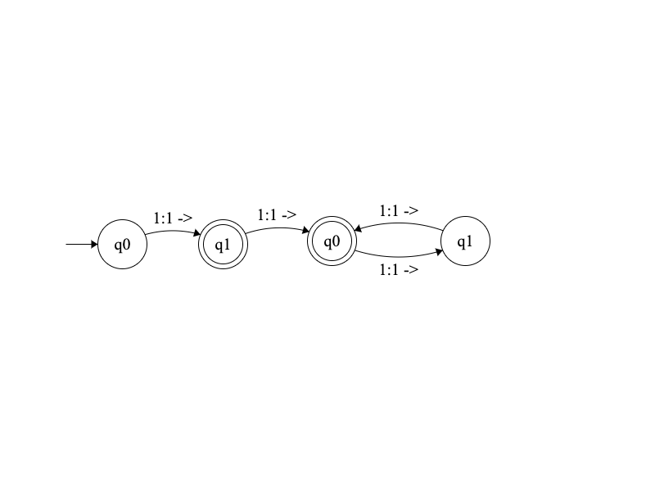

1. Draw a Turing machine that computes ⌈n/2⌉ for unary numbers. Shape

   Description automatically generated with low confidence